**Ideation Phase**

**Define the Problem Statements**

|  |  |
| --- | --- |
| Date | 19 September 2022 |
| Team ID | PNT2022TMID26330 |
| Project Name | Project – Smart Farmer – IoT Enabled Smart Farming Application |
| Maximum Marks | 2 Marks |

**Customer Problem Statement Template:**

The traditional agriculture cannot meet modern agricultural need. Thus, it is very important to turn towards modernization of existing methods. The IoT-based agriculture system helps the farmer in monitoring different parameters of his field like soil moisture, temperature, and humidity using some sensors through a web or mobile application even if the farmers are not near their field .

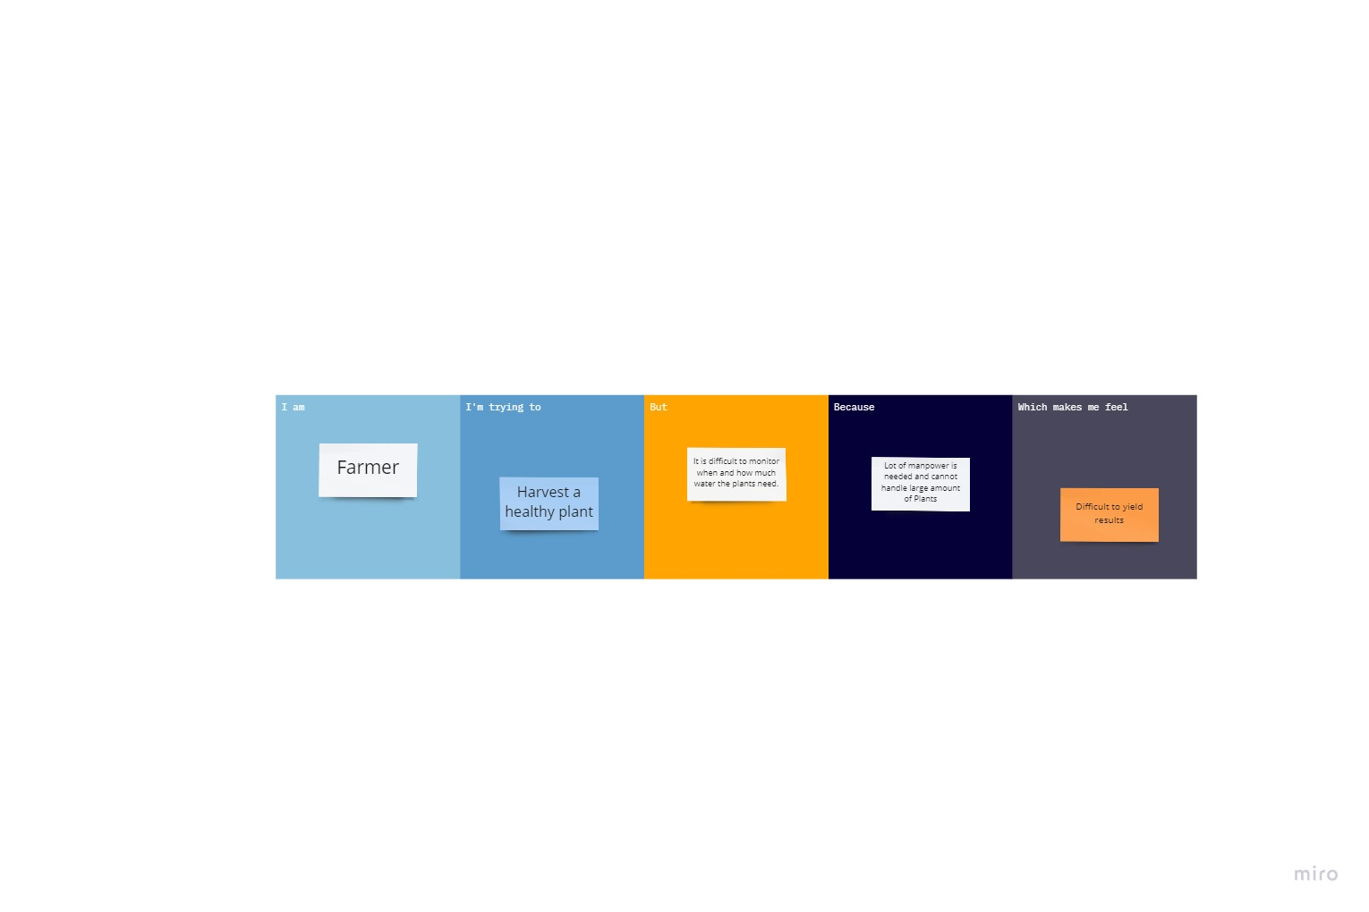

|  |  |  |  |  |  |
| --- | --- | --- | --- | --- | --- |
| **Problem Statement (PS)** | **I am (Customer)** | **I’m trying to** | **But** | **Because** | **Which makes me feel** |
| PS-1 | Farmer | Harvest a healthy plant | It is difficult to monitor when and how much water the plants need. | Lot of manpower is needed and cannot handle large amount of Plants. | Difficult to yield results |